Apply Joins to SQL Queries

Project description
In this project, I investigated a recent security incident by combining data from multiple tables using SQL joins. The dataset included employees, machines, and login attempt records. By applying different types of joins—INNER JOIN, LEFT JOIN, and RIGHT JOIN—I was able to link employees to their assigned machines, identify machines without assigned users, highlight employees without assigned machines, and retrieve details about login attempts.
This activity demonstrates how SQL joins can be used to integrate related datasets and extract actionable insights in security and IT investigations.

Match employees to their machines
SELECT *
FROM machines
INNER JOIN employees
ON machines.device_id = employees.device_id;
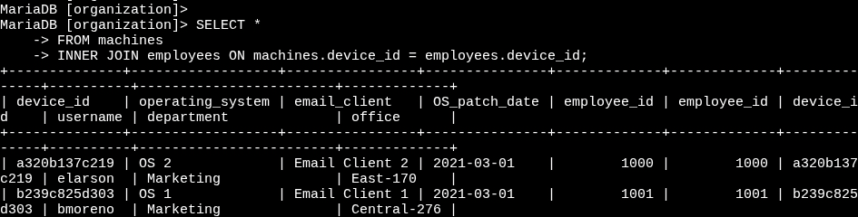
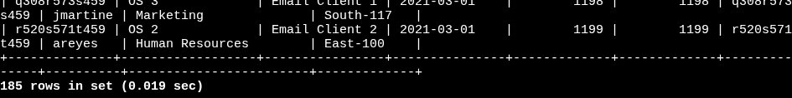
- INNER JOIN combines rows from both tables where the device_id values match.
- machines.device_id = employees.device_id ensures that only employees with assigned machines appear in the result.
This query identifies which employees are using which machines.
- Result: 185 rows returned.

Return more data
Left join – all machines and any employees assigned to them
SELECT *
FROM machines
LEFT JOIN employees
ON machines.device_id = employees.device_id;
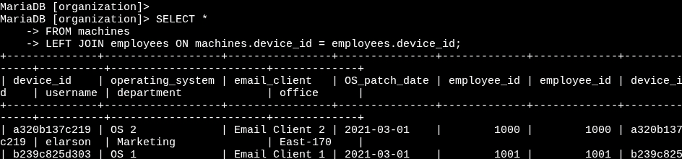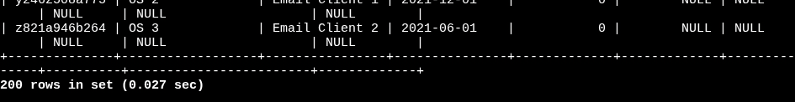
- LEFT JOIN returns all records from the left table (machines), even if there is no match in employees.
- Machines without assigned employees will still appear in the results, with NULL values for employee fields.
This helps identify machines not currently assigned to anyone.
- Result: Last username value returned → NULL.

Right join – all employees and any machines assigned to them
SELECT *
FROM machines
RIGHT JOIN employees
ON machines.device_id = employees.device_id;
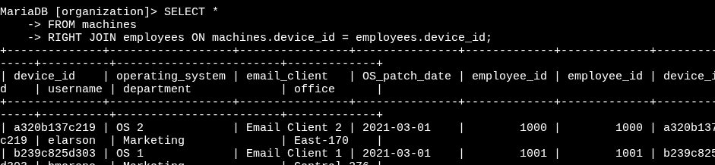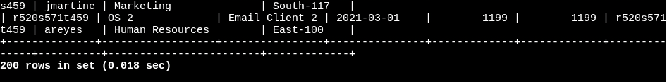
- RIGHT JOIN returns all records from the right table (employees), even if there is no match in machines.
- Employees without a machine assignment still appear in the results, with NULL values for machine fields.

This helps identify employees who don’t currently have a machine.
- Result: Last username value returned → areyes.

Retrieve login attempt data
SELECT *
FROM employees
INNER JOIN log_in_attempts
ON employees.username = log_in_attempts.username;
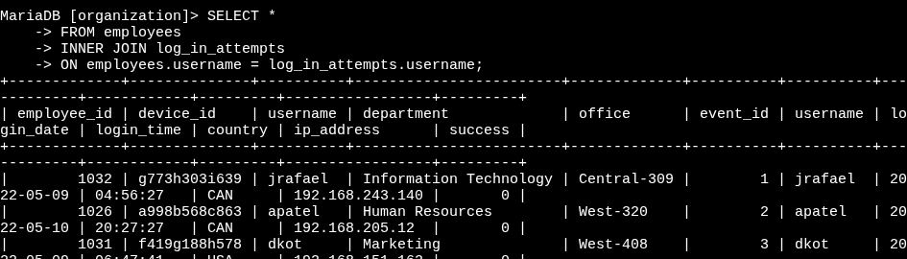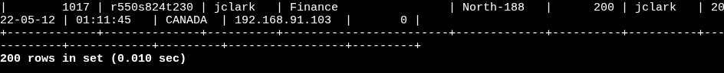
- This INNER JOIN links employees to their login attempt activity.
- employees.username = log_in_attempts.username ensures only login attempts by valid employees are shown.

This query returns all login attempts made by employees.
- Result: 200 records returned.

Summary
In this project, I used SQL joins to investigate a potential security incident by linking employees, machines, and login attempt data. An inner join helped match employees to their machines, while left and right joins identified machines without users and employees without machines. Finally, another inner join connected employees to their login attempts, giving visibility into system activity during the incident.
This project highlights how SQL joins can combine multiple datasets into a unified view, supporting both security investigations and IT operations. These techniques are crucial for understanding relationships between entities in a database and identifying gaps or anomalies in organizational systems.

